

**Activity sheet: Getting to know dams, weirs and water channels**

1. 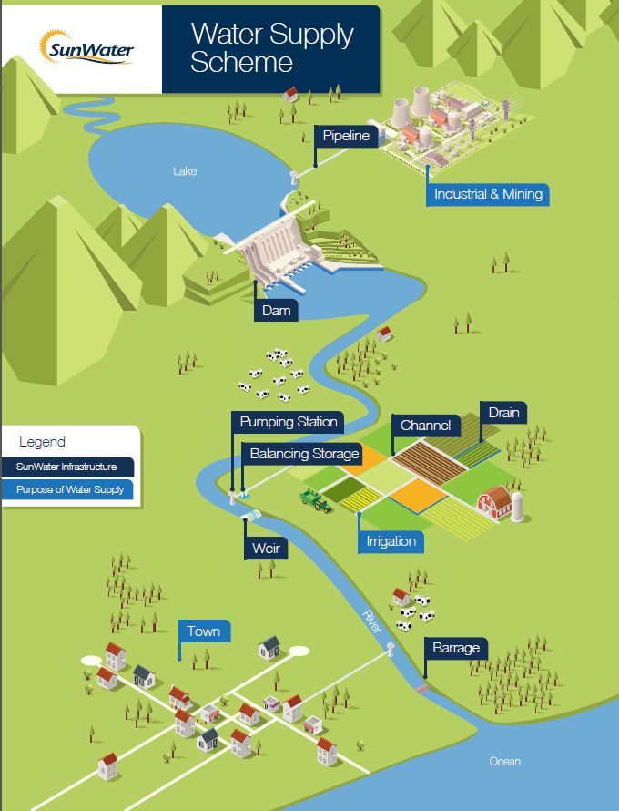Can you find the words **Dam**, **Weir** and **Channel** on the picture below? Circle each of them with a different colour pen.
2. Write the word **Dam**, **Weir** or **Water Channel** to match each picture below.

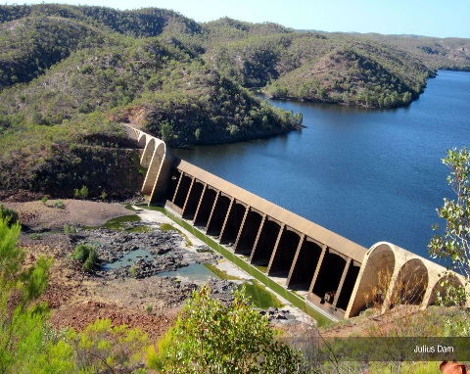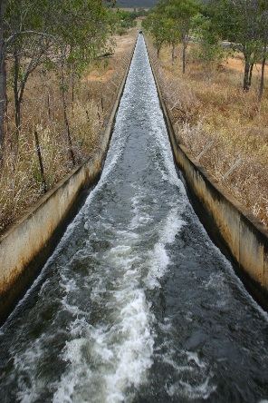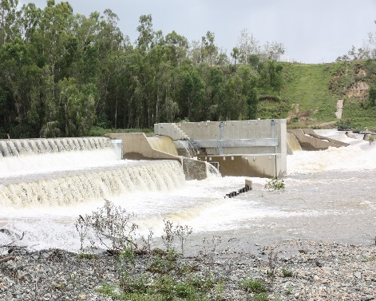

__ __ __ __ __ __ __ __ __ __ __ __

__ __ __ __ __ __ __

1. Using the pictures above, draw an arrow to match the word with the correct description.

**Dam** A passage dug into the ground to send water from one place to another.

**Weir** A big wall built across a river to store water for later use. Water is released via a **spillway**.

**Water channel** A **barrier** built across a river. Water can be released and flow over this barrier to be used further downstream.

1. Water from the dams, weirs and water channels is used for many different purposes. On the picture above circle the following pictures/ words:
   1. town/ houses b. fields
2. factories (industrial and mining) d. cows
3. Write a sentence to describe how we use water in our homes.

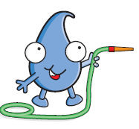



Activity sheet: Understanding the hidden dangers - what lies beneath?

1. Play the video ‘Play Safe…Stay Away!’ to the students. The video is divided into three sections: Water Channels, Weirs and Dams. At the end of each section stop the video and assess students’ understanding by asking the following questions to the group:



**Water Channels**

1. What is the name of the cartoon water drop?
2. Is the water in the water channel clean?
3. What do the gates across the water channel do?
4. Does the depth of water in a water channel change?
5. What are the sides of the water channel like?

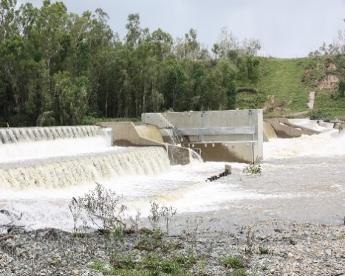**Weirs**

1. What happens at a weir when it rains?
2. Are you allowed to swim in the weir?
3. What else is under the water that could trap you?
4. What does Blue ask you to remember? Can you finish the rest of the sentence?

Play safe…______ ______ ?

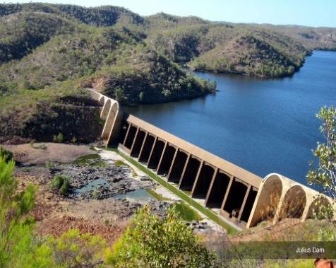**Dams**

1. What does a dam do?
2. What is the first thing you should do when you arrive at a dam?
3. What did the danger signs show? What were you not allowed to do within 200 metres of the dam wall?
4. Do you know what ‘not permitted’ means?
5. Should you go near water without a grown up?

Watch the end of the video that summarises the key safety messages.

1. After watching the ‘Play Safe…Stay Away!’ video, there are some key words that you should recognise. Read these words aloud and make sure you understand their meaning. Then see if you can find them hidden in the word search. They may be forwards, backwards or diagonally. The first one has been done for you.

**STAY AWAY WATER CHANNEL DANGER SIGNS**

**DIRTY WATER RELEASED SLIPPERY**

**WEIR FAST CURRENT PIPES**

**TRAP BLUE DAM WALL**

**PICNIC PLAY SAFE DAM**

|  |  |  |  |  |  |  |  |  |  |  |  |  |
| --- | --- | --- | --- | --- | --- | --- | --- | --- | --- | --- | --- | --- |
| **D** | **T** | **H** | **E** | **D** | **R** | **E** | **D** | **A** | **R** | **I** | **E** | **W** |
| **I** | **R** | **S** | **T** | **A** | **Y** | **A** | **W** | **A** | **Y** | **E** | **H** | **A** |
| **R** | **I** | **N** | **S** | **M** | **D** | **D** | **E** | **E** | **M** | **N** | **D** | **T** |
| **T** | **A** | **G** | **L** | **W** | **N** | **G** | **E** | **R** | **U** | **S** | **Y** | **E** |
| **Y** | **O** | **I** | **I** | **A** | **D** | **E** | **S** | **A** | **E** | **L** | **E** | **R** |
| **W** | **U** | **S** | **P** | **L** | **C** | **A** | **E** | **N** | **N** | **O** | **B** | **C** |
| **A** | **T** | **R** | **P** | **L** | **S** | **F** | **E** | **E** | **R** | **E** | **A** | **H** |
| **T** | **D** | **E** | **E** | **T** | **A** | **H** | **E** | **P** | **W** | **A** | **R** | **A** |
| **E** | **N** | **G** | **R** | **S** | **I** | **N** | **G** | **S** | **A** | **I** | **G** | **N** |
| **R** | **N** | **N** | **Y** | **S** | **A** | **N** | **D** | **S** | **T** | **R** | **A** | **N** |
| **Y** | **F** | **A** | **S** | **T** | **C** | **U** | **R** | **R** | **E** | **N** | **T** | **E** |
| **S** | **L** | **D** | **A** | **F** | **C** | **I** | **N** | **C** | **I** | **P** | **E** | **L** |
| **P** | **I** | **P** | **E** | **S** | **S** | **T** | **A** | **Y** | **A** | **W** | **A** | **Y** |

1. Can you complete this important safety message using the remaining letters in the word search? Start from the top left, and read across each row from left to right.

__ __ __ __ __ __ __ __ __ __ __ __ __ __ __ __ __ __ __ __ __

__ __ __ __ __ __ __ __ __ __ __ __.

__ __ __ __ __ __ __ __ __ __ __ __ __ __ __ __ __ __ __ __ __ __

__ __ __ __ __ __ __ __ , __ __ __ __ __ __ __ __ .

1. Use the template provided on the next page to design your own poster that shows some of the dangers of being around dams, weirs and water channels. You can either use the key safety message shown on the graphic below or you can make up your own safety message for Blue to say?

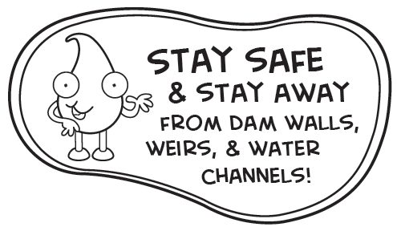

Design a poster- recognising the dangers around dams, weirs and water channels





**Activity sheet: Play Safe…Stay Away! Recognising the warning signs**

1. Write the correct safety message next to each of the warning signs using one of the descriptions provided in the box below.

|  |  |  |  |  |
| --- | --- | --- | --- | --- |
|  |  |  |  |  |
|  |  |  |  |  |
|  |  |  |  |  |
|  |  |  |  |  |

|  |  |
| --- | --- |
| Logs under the water | Underwater pipes |
| No jet skiing | Uneven/ slippery surface |
| No fishing | No swimming |
| Deep water | No access- people not allowed |

2. Draw the picture inside each of the warning sign outlines given below using the warning signs in the table above to help you.

Danger- underwater pipes

No fishing

Slippery/ uneven surface

No swimming

Danger- underwater logs

1. What three shapes are the warning signs?

­­­

­­­­­­­­­­­­­

1. What colours are used on the warning signs?

­

1. ­­Warning signs at dams, weirs and water channels are important because…