# Activity Sheet Answers – Prep to Grade 2

Lesson Plan 1: Getting to know Dams, Weirs and Water Channels

1. Write the word **dam**, **weir** or **water channel** to match each picture below.

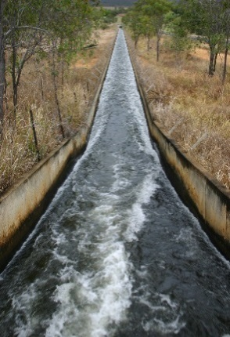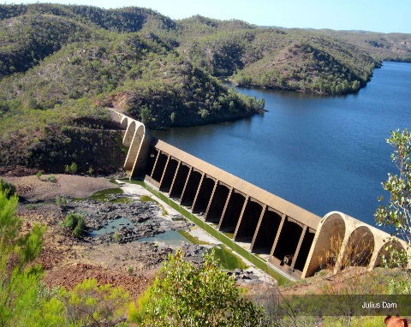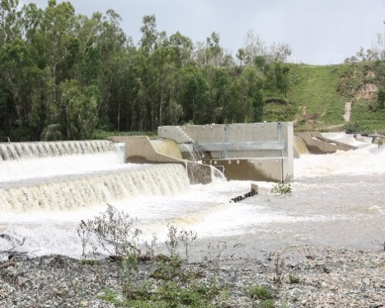 **Weir Water channel Dam**

1. Using the pictures above, draw an arrow to match the word with the correct description.

**Dam** A passage dug into the ground to send water from one place to another.

**Weir**  A big wall built across a river to store water for later use. Water is released via a **spillway**.

**Water channel** A **barrier** built across a river. Water can be released and flow over this barrier to be used further downstream.

1. Write a sentence to describe how we use water in our homes.
   1. To bath and shower
   2. To wash our dishes
   3. To wash our clothes
   4. To water the garden
   5. To clean the car
   6. To cook with

Lesson Plan 2: Understanding the hidden dangers- what lies beneath?

1. Play the video ‘Play Safe…Stay Away!’ to the students. The video is divided into three sections: Water Channels, Weirs and Dams. At the end of each section stop the video and assess students’ understanding by asking the following questions to the group:

**Water Channels**

* 1. What is the name of the cartoon water drop? Blue
  2. Is the water in the water channel clean? It looks clean but there are nasty things in the water (e.g. bacteria and blue-green algae) that could make you sick.
  3. What do the gates across the water channel do? Gates let the water out very quickly and you could become trapped in deep water. It might look calm, but the water can move really fast and you might get sucked under.
  4. Does the depth of water in a water channel change? Yes.
  5. What are the sides of the water channel like? Very slippery with algae and moss. If you fell in, you might not be able to get out again.

**Weirs**

1. What happens at a weir when it rains? The water flows over the top.
2. Are you allowed to swim in the weir? No because the water can be released at any time and fill the area very quickly.
3. What else is under the water that could trap you? Underwater pipes and logs.
4. What does Blue ask you to remember? Can you finish the rest of the sentence? Play safe… Stay Away!

**Dams**

1. What does a dam do? A dam holds back water but the water can be released at any time. A dam holds millions of litres of water.
2. What is the first thing you should do when you arrive at a dam? Look for the danger signs.
3. What did the danger signs show? What were you not allowed to do within 200 metres of the dam wall? No boating, swimming or fishing allowed within 200 metres of the dam wall.
4. Do you know what ‘not permitted’ means? Not allowed to do something.
5. Should you go near water without a grown up? No.
6. After watching the ‘Play Safe…Stay Away!’ video, there are some key words that you should recognise. Read these words aloud and make sure you understand their meaning. Then see if you can find them hidden in the wordsearch.

**STAY AWAY WATER CHANNEL DANGER SIGNS**

**DIRTY WATER RELEASED SLIPPERY**

**WEIR FAST CURRENT PIPES**

**TRAP BLUE DAM WALL**

**PICNIC PLAY SAFE DAM**

|  |  |  |  |  |  |  |  |  |  |  |  |  |
| --- | --- | --- | --- | --- | --- | --- | --- | --- | --- | --- | --- | --- |
| **D** | **T** | **H** | **E** | **D** | **R** | **E** | **D** | **A** | **R** | **I** | **E** | **W** |
| **I** | **R** | **S** | **T** | **A** | **Y** | **A** | **W** | **A** | **Y** | **E** | **H** | **A** |
| **R** | **I** | **N** | **S** | **M** | **D** | **D** | **E** | **E** | **M** | **N** | **D** | **T** |
| **T** | **A** | **G** | **L** | **W** | **N** | **G** | **E** | **R** | **U** | **S** | **Y** | **E** |
| **Y** | **O** | **I** | **I** | **A** | **D** | **E** | **S** | **A** | **E** | **L** | **E** | **R** |
| **W** | **U** | **S** | **P** | **L** | **C** | **A** | **E** | **N** | **N** | **O** | **B** | **C** |
| **A** | **T** | **R** | **P** | **L** | **S** | **F** | **E** | **E** | **R** | **E** | **A** | **H** |
| **T** | **D** | **E** | **E** | **T** | **A** | **H** | **E** | **P** | **W** | **A** | **R** | **A** |
| **E** | **N** | **G** | **R** | **S** | **I** | **N** | **G** | **S** | **A** | **I** | **G** | **N** |
| **R** | **N** | **N** | **Y** | **S** | **A** | **N** | **D** | **S** | **T** | **R** | **A** | **N** |
| **Y** | **F** | **A** | **S** | **T** | **C** | **U** | **R** | **R** | **E** | **N** | **T** | **E** |
| **S** | **L** | **D** | **A** | **F** | **C** | **I** | **N** | **C** | **I** | **P** | **E** | **L** |
| **P** | **I** | **P** | **E** | **S** | **S** | **T** | **A** | **Y** | **A** | **W** | **A** | **Y** |

1. Can you complete this important safety message using the remaining letters in the wordsearch? Start from the top left, and read across each row from left to right.

**THERE ARE HIDDEN DANGERS YOU CANNOT SEE. READ THE WARNING SIGNS AND STAY SAFE, STAY AWAY.**

Lesson Plan 3: Play Safe…Stay Away! Recognising the warning signs

1. Write the correct safety message next to each of the warning signs using one of the descriptions provided in the box below.

|  |  |  |  |  |
| --- | --- | --- | --- | --- |
|  | No swimming |  |  | No jet skiing |
|  | Uneven/ slippery surface |  |  | No access- people not allowed |
|  | No fishing |  |  | Logs under the water |
|  | Underwater pipes |  |  | Deep water |

1. What three shapes are the warning signs? Circle, triangle and diamond.
2. What colours are used on the warning signs? Red and yellow with black graphics
3. Warning signs at dams, weirs and are channels are important because… they warn people about the possible dangers and hazards and let people know what they are not allowed to do. Warning signs are there to ensure everyone stays safe.