

Activity sheet 1: Discovering dams, weirs and water channels

1. The picture below shows how the water supply is used between the lake and the ocean. Use the picture to help you to fill in the blanks in the passage of text on the next page using the words provided in the table.

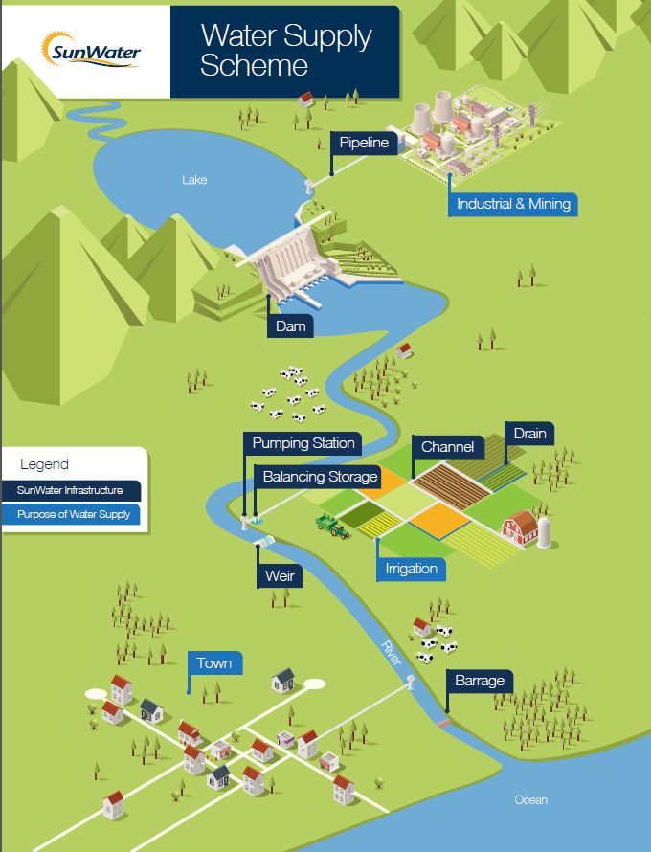

**Fill in the blanks:**

When it ­­­­­­­­­­­­­­­­­­­__________ water enters rivers and ­­_________. These eventually flow out to the _____________. Some of the water soaks into the ___________, this is known as groundwater.

A ___________ is a big wall that is built across a valley. A large ___________ is formed behind the dam wall. A dam helps to ___________ the flow of water or raise the level of water held within a ___________________ area.

Dams play a very important role in supplying water to __________, farms and industry. We use the water in our _______________ and schools, and farmers use the water to ____________ their crops.

During periods of heavy rain, the ­­­___________ levels in the dams will ___________. Water is safely released from the dam via a _____________ or release gate.

A weir is a _______________ built across a river or creek to control the flow of water that is released to users downstream. The main difference between a dam and a ___________ is that water flows over the top (crest) of weir and not through a release gate or spillway.

A ______________ _________________ is like a passage dug into the ground. It sends water from one location to another for _______________ to water (irrigate) their crops.

Playing in dams, weirs and water channels can be very _______________. It is important to pay attention to the ________________ signs and follow directions.

**Use these words to fill in the blank spaces:**

|  |  |  |  |  |
| --- | --- | --- | --- | --- |
| **dam** | **towns** | **weir** | **creeks** | **lake** |
| **water** | **rains** | **homes** | **spillway** | **rise** |
| **control** | **barrier** | **ground** | **water channel** | **warning** |
| **dangerous** | **catchment** | **farmers** | **irrigate** | **ocean** |

1. Write the word **Dam**, **Weir** or **Water channel** to match each picture below.

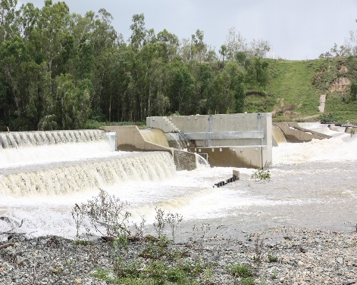 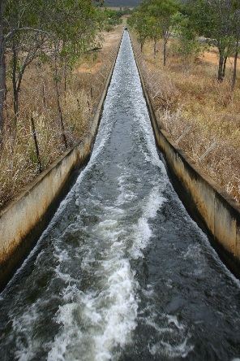 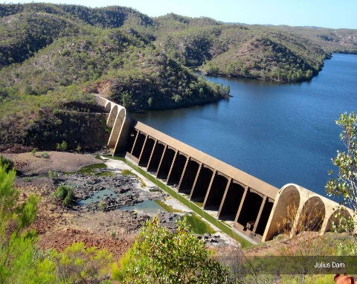

____________________ ___________________ ___________________

1. The ‘Water Supply Scheme’ picture shows the water supply being used in towns, by farmers, and in industry and mining. Write a couple of sentences describing how the water could be used in each of these areas:

**Towns:**

______________________________________________________________________

______________________________________________________________________

______________________________________________________________________

**Farmers:**

______________________________________________________________________

______________________________________________________________________

**Industry (such as mines and factories):**

______________________________________________________________________

______________________________________________________________________

______________________________________________________________________

1. In periods of dry weather (drought) the water levels in the dam will fall. What steps could we take to try to save (conserve) water in periods of drought? Write down four ideas below.
   1. ______________________________________________________________
   2. ______________________________________________________________
   3. ______________________________________________________________
   4. ______________________________________________________________

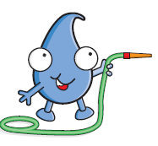

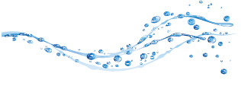



Activity sheet 2: Understanding the hidden dangers- what lies beneath?

1. Watch the video ‘Play Safe…Stay Away!’ The video is divided into three sections: Water Channels, Weirs and Dams. At the end of each section, the video will be stopped allowing you to answer the following questions. Write the answers into your books using full sentences e.g. Question 1a. The name of the cartoon water drop is….



**Water Channels**

1. What is the name of the cartoon water drop?
2. Is the water in the water channel clean?
3. What do the gates across the water channel do?
4. Does the depth of water in a water channel change?
5. What are the sides of the water channel like?

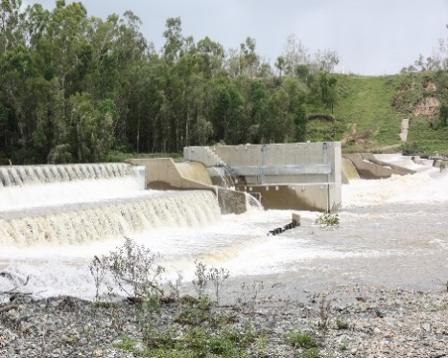**Weirs**

1. What happens at a weir when it rains?
2. Are you allowed to swim in the weir?
3. What else is under the water that could trap you?
4. What does Blue ask you to remember? Can you finish the rest of the sentence?

Play safe…______ ______?

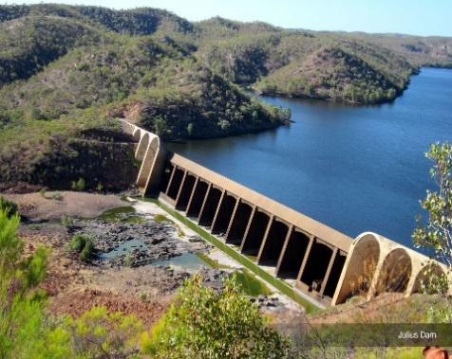**Dams**

1. What does a dam do?
2. What is the first thing you should do when you arrive at a dam?
3. What did the danger signs show? What were you not allowed to do within 200 metres of the dam wall?
4. Do you know what ‘not permitted’ means?
5. Should you go near water without a grown up?

Watch the end of the video that summarises the key safety messages.

1. After watching the ‘Play Safe…Stay Away!’ video, there are some key words that you should recognise. Make sure you understand their meaning and then see if you can find them hidden in the wordsearch. They may be forwards, backwards or diagonally. The first one has been done for you.

**STAY AWAY WATER CHANNEL DANGER SIGNS**

**DIRTY WATER RELEASED SLIPPERY**

**WEIR FAST CURRENT PIPES**

**TRAP BLUE DAM WALL**

**PICNIC PLAY SAFE DAM**

|  |  |  |  |  |  |  |  |  |  |  |  |  |
| --- | --- | --- | --- | --- | --- | --- | --- | --- | --- | --- | --- | --- |
| **D** | **T** | **H** | **E** | **D** | **R** | **E** | **D** | **A** | **R** | **I** | **E** | **W** |
| **I** | **R** | **S** | **T** | **A** | **Y** | **A** | **W** | **A** | **Y** | **E** | **H** | **A** |
| **R** | **I** | **N** | **S** | **M** | **D** | **D** | **E** | **E** | **M** | **N** | **D** | **T** |
| **T** | **A** | **G** | **L** | **W** | **N** | **G** | **E** | **R** | **U** | **S** | **Y** | **E** |
| **Y** | **O** | **I** | **I** | **A** | **D** | **E** | **S** | **A** | **E** | **L** | **E** | **R** |
| **W** | **U** | **S** | **P** | **L** | **C** | **A** | **E** | **N** | **N** | **O** | **B** | **C** |
| **A** | **T** | **R** | **P** | **L** | **S** | **F** | **E** | **E** | **R** | **E** | **A** | **H** |
| **T** | **D** | **E** | **E** | **T** | **A** | **H** | **E** | **P** | **W** | **A** | **R** | **A** |
| **E** | **N** | **G** | **R** | **S** | **I** | **N** | **G** | **S** | **A** | **I** | **G** | **N** |
| **R** | **N** | **N** | **Y** | **S** | **A** | **N** | **D** | **S** | **T** | **R** | **A** | **N** |
| **Y** | **F** | **A** | **S** | **T** | **C** | **U** | **R** | **R** | **E** | **N** | **T** | **E** |
| **S** | **L** | **D** | **A** | **F** | **C** | **I** | **N** | **C** | **I** | **P** | **E** | **L** |
| **P** | **I** | **P** | **E** | **S** | **S** | **T** | **A** | **Y** | **A** | **W** | **A** | **Y** |

1. Can you complete this important safety message using the remaining letters in the wordsearch? Start from the top left and read across each row from left to right.

__ __ __ __ __ __ __ __ __ __ __ __ __ __ __ __ __ __ __ __ __

__ __ __ __ __ __ __ __ __ __ __ __.

__ __ __ __ __ __ __ __ __ __ __ __ __ __ __ __ __ __ __ __ __ __

__ __ __ __ __ __ __ __ , __ __ __ __ __ __ __ __ .

1. Imagine the summer school holidays are just around the corner. Write an article to feature in your school newsletter that reminds students and parents that are visiting a local dam to stay safe and consider the warning signs.

Your article should include:

* + The name of your local dam and where it is
  + What recreational facilities are available at the dam e.g. boat ramp, picnic facilities, BBQs etc. You can find this information on the [SunWater website](http://www.sunwater.com.au/sustainability/community/recreational-facilities)
  + Some of the risks and hidden dangers that they should be aware of
  + The importance of reading the warning signs
  + What other steps they can take to ensure they enjoy the surroundings whilst staying safe

To help you, why not research some of the dam safety media articles available on the SunWater website that may assist you with writing your article:

* [SunWater reminds campers of safety requirements at Wuruma Dam](http://www.sunwater.com.au/about-sunwater/media-room/latest-news/latest-news/2016/wuruma-dam-over-easter)
* [Stay safe around dams this holiday season](http://www.sunwater.com.au/about-sunwater/media-room/latest-news/latest-news/2015/stay-safe-around-dams-this-holiday-season)
* [Blue-green algae levels in waterways over summer months](http://www.sunwater.com.au/about-sunwater/media-room/latest-news/latest-news/2016/bga-warning)
* [Fishermen warned to put safety first](http://www.sunwater.com.au/about-sunwater/media-room/latest-news/latest-news/2016/anglers-warned)
* [Importance of water safety in the summer season](http://www.sunwater.com.au/about-sunwater/media-room/latest-news/latest-news/2016/water-safety-silly-season)
* [Parents urged to talk about dam safety](http://www.sunwater.com.au/about-sunwater/media-room/latest-news/latest-news/2016/easter-dam-safety)



  
1. What do each of these warning signs show? Write a short description in the table below.

Activity sheet 3: Play Safe…Stay Away! Recognising the warning signs

|  |  |  |  |  |
| --- | --- | --- | --- | --- |
|  |  |  |  |  |
|  |  |  |  |  |
|  |  |  |  |  |
|  |  |  |  |  |

1. Look at the SunWater warning sign then answer the questions below in your books.

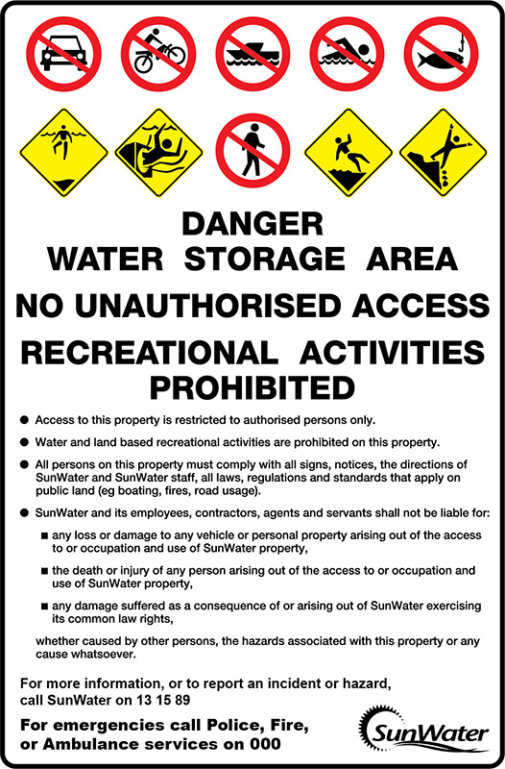

1. What six things are you **not** allowed to do at this site?
2. What are the four potential hazards at this site that could be a safety issue?
3. Use a dictionary or the internet to write out the meaning of the following words:

**unauthorised recreational activities prohibited comply hazards**

1. Finish this sentence. Warning signs at dams, weirs and water channels are important because….

3. Using the template provided below, design your own warning sign for your local dam, weir or water channel. Using the safety signs shown in the table above or from the PowerPoint presentation, to show what potential hazards may be present and what people are not allowed to do at the site.

