# Activity Sheet Answers – Grades 3 to 4

Lesson Plan 1: Getting to know Dams, Weirs and Water Channels

1. The picture below shows how the water supply is used between the lake and the ocean. Use the picture to help you to fill in the blanks in the passage of text on the next page using the words provided in the table

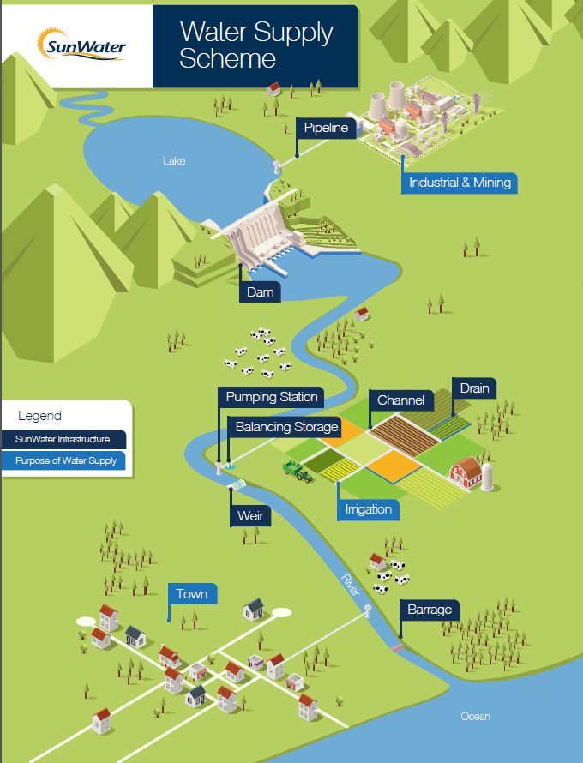

When it ­­­­­­­­­­­­­­­­­­­**rains** water enters rivers and **­­creeks**. These eventually flow out to the **ocean**. Some of the water soaks into the **ground**, this is known as groundwater.

A **dam** is a big wall that is built across a valley. A large l**ake** is formed behind the dam wall. A dam helps to **control** the flow of water or raise the level of water held within a **catchment** area.

Dams play a very important role in supplying water to **towns**, farms and industry. We use the water in our **homes** and schools, and farmers use the water to **irrigate** their crops.

During periods of heavy rain, the **water** levels in the dams will **rise**. Water is safely released from the dam via a **spillway** or release gate.

A weir is a **barrier** built across a river or creek to control the flow of water that is released to users downstream. The main difference between a dam and a **weir** is that water flows over the top (crest) of weir and not through a release gate or spillway.

A **water channel** is like a passage dug into the ground. It sends water from one location to another for **farmers** to water (irrigate) their crops.

Playing in dams, weirs and water channels can be very **dangerous**. It is important to pay attention to the **warning** signs and follow directions.

**Use these words to fill in the blank spaces:**

|  |  |  |  |  |
| --- | --- | --- | --- | --- |
| **dam** | **towns** | **weir** | **creeks** | **lake** |
| **water** | **rains** | **homes** | **spillway** | **rise** |
| **control** | **barrier** | **ground** | **water channel** | **warning** |
| **dangerous** | **catchment** | **farmers** | **irrigate** | **ocean** |

1. Write the word **Dam**, **Weir** or **Water channel** to match each picture below.

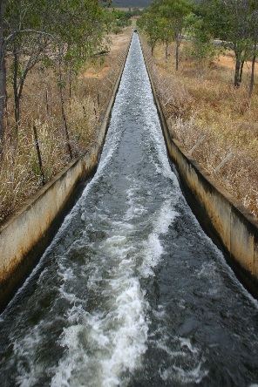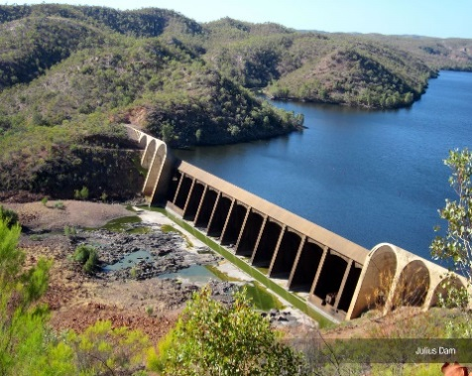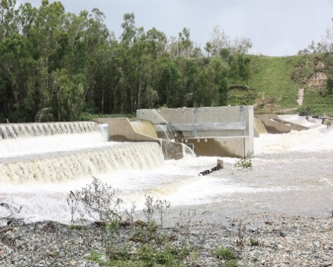

**Weir Water channel Dam**

1. The ‘Water Supply Scheme’ picture shows the water supply being used in towns, by farmers, and in industry and mining. Write a couple of sentences describing how the water could be used in each of these areas:

**Towns:**

* For drinking water in our homes and for cooking, cleaning, washing and watering the garden
* For use in schools and businesses
* To water parks and gardens

**Farmers:**

* To irrigate their crops
* To water their livestock

**Industry (such as mines and factories):**

* To operate machinery
* To cool machinery
* To assist in the manufacturing process

1. In periods of dry weather (drought) the water levels in the dam will fall. What steps could we take to try to save (conserve) water in periods of drought? Write down four ideas below. Examples include:
   1. Take shorter showers
   2. Only use the half flush in the toilet
   3. Make sure the washing amchine has a full load
   4. Wash up at the end of the day and recycle the washing up water on the garden
   5. Water the garden in the morning or evening when it is cooler

Lesson Plan 2: Understanding the hidden dangers - what lies beneath?

1. Play the video ‘Play Safe…Stay Away!’ to the students. The video is divided into three sections: Water Channels, Weirs and Dams. At the end of each section stop the video and assess students’ understanding by asking the following questions to the group:

**Water Channels**

1. What is the name of the cartoon water drop? The name of the cartoon water drop is Blue.
2. Is the water in the water channel clean? No, the water in the water channel is not clean. It looks clean but there are are nasty things in the water (e.g. bacteria and blue-green algae) that could make you sick.
3. What do the gates across the water channel do? The gates across the water channel let the water out very quickly and you could become trapped in deep water. It might look calm, but the water can move really fast and you might get sucked under.
4. Does the depth of water in a water channel change? Yes, the depth of water in a water channel does change.
5. What are the sides of the water channel like? The sides of the water channel are very slippery with algae and moss. If you fell in, you might not be able to get out again.

**Weirs**

1. What happens at a weir when it rains? When it rains at a weir, the water flows over the top.
2. Are you allowed to swim in the weir? Why not? No, you are not allowed to swim in the weir because the water can be released at any time and fill the area very quickly
3. What else is under the water that could trap you? There are pipes and logs under the water that could trap you
4. What does Blue ask you to remember? Can you finish the rest of the sentence? Play safe… Stay Away!

**Dams**

1. What does a dam do? A dam holds back water but the water can be released at any time. A dam hold millions of litres of water.
2. What is the first thing you should do when you arrive at a dam? When you arrive at a dam, the first thing you should do is look for the danger signs.
3. What did the danger signs show? What were you not allowed to do within 200 metres of the dam wall? The danger signs showed that no boating, swimming or fishing was allowed within 200 metres of the dam wall
4. Do you know what ‘not permitted’ means? Not permitted means you are not allowed to do something.
5. Should you go near water without a grown up? No, you should not go near water without a grown up.
6. After watching the ‘Play Safe…Stay Away!’ video, there are some key words that you should recognise. Make sure you understand their meaning and then see if you can find them hidden in the wordsearch. They may be forwards, backwards or diagonally. The first one has been done for you.

**STAY AWAY WATER CHANNEL DANGER SIGNS**

**DIRTY WATER RELEASED SLIPPERY**

**WEIR FAST CURRENT PIPES**

**TRAP BLUE DAM WALL**

**PICNIC PLAY SAFE DAM**

|  |  |  |  |  |  |  |  |  |  |  |  |  |
| --- | --- | --- | --- | --- | --- | --- | --- | --- | --- | --- | --- | --- |
| **D** | **T** | **H** | **E** | **D** | **R** | **E** | **D** | **A** | **R** | **I** | **E** | **W** |
| **I** | **R** | **S** | **T** | **A** | **Y** | **A** | **W** | **A** | **Y** | **E** | **H** | **A** |
| **R** | **I** | **N** | **S** | **M** | **D** | **D** | **E** | **E** | **M** | **N** | **D** | **T** |
| **T** | **A** | **G** | **L** | **W** | **N** | **G** | **E** | **R** | **U** | **S** | **Y** | **E** |
| **Y** | **O** | **I** | **I** | **A** | **D** | **E** | **S** | **A** | **E** | **L** | **E** | **R** |
| **W** | **U** | **S** | **P** | **L** | **C** | **A** | **E** | **N** | **N** | **O** | **B** | **C** |
| **A** | **T** | **R** | **P** | **L** | **S** | **F** | **E** | **E** | **R** | **E** | **A** | **H** |
| **T** | **D** | **E** | **E** | **T** | **A** | **H** | **E** | **P** | **W** | **A** | **R** | **A** |
| **E** | **N** | **G** | **R** | **S** | **I** | **N** | **G** | **S** | **A** | **I** | **G** | **N** |
| **R** | **N** | **N** | **Y** | **S** | **A** | **N** | **D** | **S** | **T** | **R** | **A** | **N** |
| **Y** | **F** | **A** | **S** | **T** | **C** | **U** | **R** | **R** | **E** | **N** | **T** | **E** |
| **S** | **L** | **D** | **A** | **F** | **C** | **I** | **N** | **C** | **I** | **P** | **E** | **L** |
| **P** | **I** | **P** | **E** | **S** | **S** | **T** | **A** | **Y** | **A** | **W** | **A** | **Y** |

1. Can you complete this important safety message using the remaining letters in the wordsearch? Start from the top left, and read across each row from left to right.

**THERE ARE HIDDEN DANGERS YOU CANNOT SEE. READ THE WARNING SIGNS AND STAY SAFE, STAY AWAY**.

Lesson Plan 3: Play Safe…Stay Away! Recognising the warning signs

1. What do each of these warning signs show? Write a short description in the table below.

|  |  |  |  |  |
| --- | --- | --- | --- | --- |
|  | No swimming |  |  | No jet skiing |
|  | Uneven/ slippery surface |  |  | No access- people not allowed |
|  | No fishing |  |  | Logs under the water |
|  | Underwater pipes |  |  | Deep water |

1. Look at the SunWater warning sign then answer the questions below in your books.

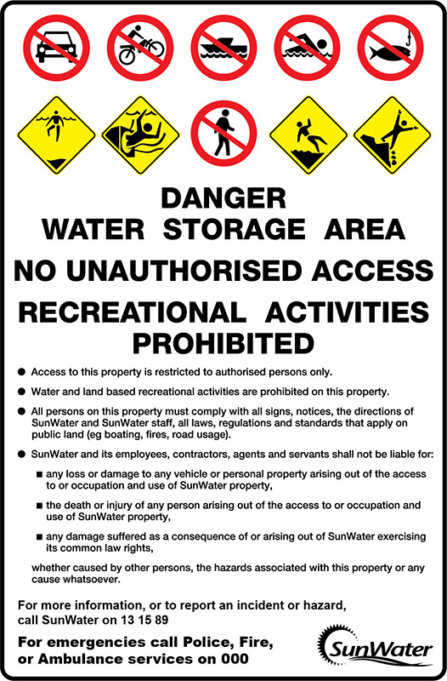

1. What six things are you **not** allowed to do at this site?

No cars, no motorbikes no boating, no swimming, no fishing and no access allowed.

1. What are the four potential hazards at this site that could be a safety issue?

Deep water, underwater pipes, uneven/ slippery surface, unstable edges.

1. Use a dictionary or the internet to write out the meaning of the following words:

* **Unauthorised-** when you do not have permission to do something
* **Recreational activities-** an activity, pastime or exercise that you enjoy doing in your spare time
* **Prohibited-** to stop someone doing something, to prevent
* **Comply-** to act in a way that meets conditions or requirements
* **Hazards-** a danger or risk

1. Finish this sentence. Warning signs at dams, weirs and water channels are important because…. they warn people about the possible dangers and hazards and let people know what they are not allowed to do. Warning signs are there to ensure everyone stays safe.